**Cell 16:**

**Cell 20:**

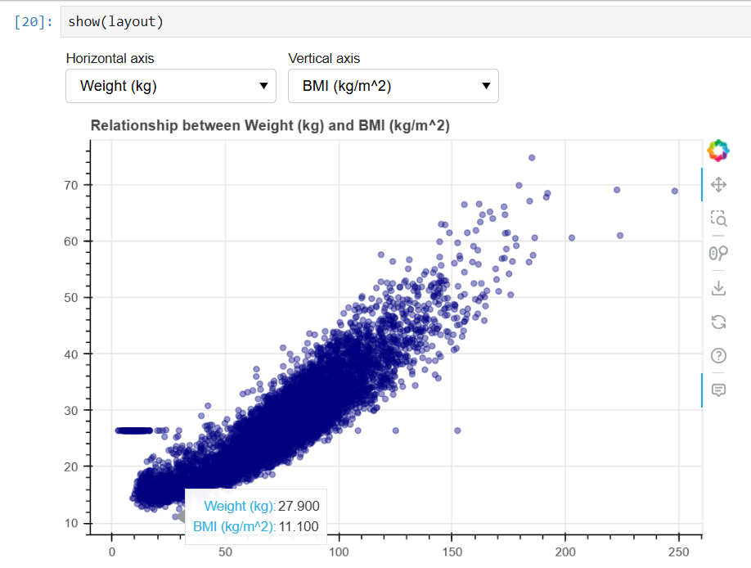

**Cell 24:**

**Cell 28:**

**Cell 32:**

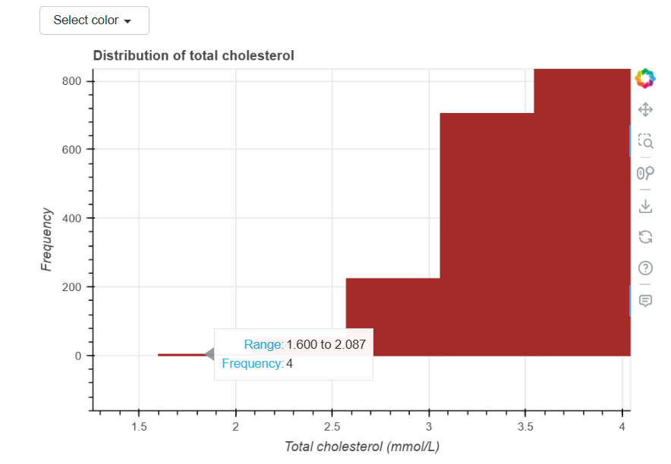

**Cell 36:**

